MC900199701[1]

**Sunday School Pie Order Form**

Name: _________________________________

Phone Number: ___________________________

**Type of Pies Available**

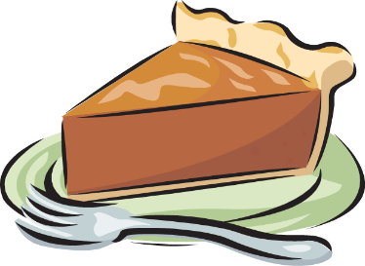

_____ Pumpkin

_____ Pecan

_____ Banana Cream

_____ Unbaked Apple

_____ Total of pies ordered at $10.00 each

Please make checks payable to LM Moravian Church with the Memo as **Sunday School Pies.**

Pick up will be in Fellowship Hall on Sunday, November 18 after the 10:00 a.m. Church Service.

**Orders due by Friday November 16, 2018**

Thank you for your order!

The proceeds will go to our annual Adopt-a-Family Program